**L.C.M. & H.C.F.(G.C.D.)**



1. The least number which is exactly divisible by 5, 8, 10, 12 and 15 is



1. 360 2) 120 3) 180 4) 240 5) 160

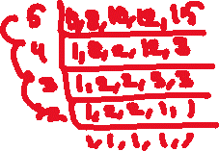

1. What could be the minimum length of the cloth in meters which can be measured an exact number of times by using any of the scales of lengths 72cm, 96cm, 120cm and 180cm?



1. 14.4 2) 12.8 3) 16.4 4) 24.4 5) 18.4

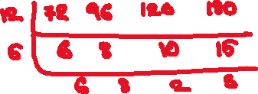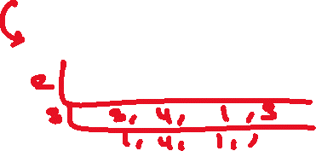

1. The L.C.M. and H.C.F. of two numbers are 1408 & 16 respectively and one of these numbers is 128. Find the second number.
2. 176 2) 156 3) 180 4) 204 5) 210



1. Four bells toll at 10, 12, 15 and 20 min respectively beginning together. After what interval of time do they toll again together?



1. 2 hours 2) 1hr 12 min 3) 1 hr 20min 4) 1hr 5) 3hrs

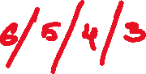

1. The least square number which is exactly divisible by 5, 6, 8, 9 and 10 is



1. 360 2) 900 3) 3600 4) 14400 5) 24400



1. Find the smallest number which when divisible by 6, 9, 12 and 15 leaves 5 as remainder in each case.



1. 175 2) 180 3) 185 4) 365 5) 280



1. When 6 or 7balls are kept in each box, 4 balls will be left out, when 8 or 9 balls are kept in each box, 4 balls left out, when 10 or 11 balls are kept in each box, 4 balls will left out, what could be the minimum number of balls?



1. 27724 2) 27728 3) 27716 4) 27720 5) 27718

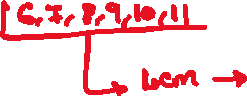

1. Find the smallest number which when increased by 7, divisible by 8, 15, 16 and 25.



1. 1193 2) 1200 3) 1207 4) 2393 5) 1225



1. Find the least number of 5 digits which is exactly divisible by 5, 10, 15 and 25.



1. 10020 2) 10050 3) 10350 4) 10120 5) 10010

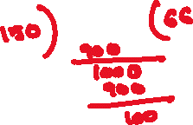

1. Find the greatest number of 4 digits which is exactly divisible by 7, 14, and 21.
2. 9988 2) 9992 3) 9996 4) 9999 5) 8889

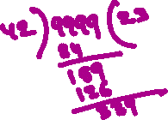

1. The greatest number, which when subtracted from the largest square number with four digits, gives a number exactly divisible by each of 25, 30, 35 and 40 is



1. 5601 2) 6501 3) 5603 4) 6503 5) 6508



1. Find the least number which when divided by 32 leaves 12 as the remainder, when divided by 40 leaves 20 as the remainder and when divided by 56 leaves 36 as the remainder
2. 1100 2) 1112 3) 1120 4) 1140 5) 1225



1. Find the least number which when divided by 4, 6, 8 and 12 leaves as the remainder 1, but when divided by 15 leaves 7 as the remainder
2. 25 2) 52 3) 73 4) 97 5) 100



1. When a rope is cut into pieces of 2m each, 1m rope will be left out, when it is cut into pieces of 5m each, 1m rope will be left out, when it is cut into pieces of 7m each, 3m rope will be left out, what could be the minimum length of the rope?
2. 21m 2) 51m 3) 31m 4) 41m 5) 45m



1. There are 65 pens and 104 pencils all are of equal size. Find the highest number of pens or pencils possible to be packed in the minimum number of equal size packets without mixing pens and pencils



1. 11 2) 12 3) 13 4) 17 5) 19



1. What could be the maximum length of the scale in centimetres which can be used to measure the length, breadth and height of a hall which are 9.80 mts., 6.65mts., & 4.55 mts., respectively exact number of the times?



1. 45 2) 35 3) 55 4) 65 5) 70

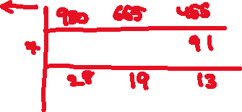

1. A boy has three kinds of stones, the first kind is 143, the second kind 182 and the third kind 208. Find the least number of heaps into which he can keep them separately by keeping the maximum possible and equal number of stones in each heap.



1. 13 2) 31 3) 41 4) 59 5) 69



1. Find the length of the largest possible square brick which could be used for paving the floor of 4.37m x 1.71m.



1. 13 cm 2) 17 cm 3) 19 cm 4) 23cm 5) 33cm



1. Find the number of square bricks of the largest possible side which could be used to pave a floor of 2.72m x 2.08m.
2. 16 2) 18 3) 221 4) 234 5) 28



1. Find the greatest number that will divide 120, 216 and 312 leaving 5, 9 and 13 as the remainder respectively
2. 13 2) 17 3) 19 4) 23 5) 43



1. Find the greatest number that will divide 1259, 1558 and 1935 leaving the same remainder in each case.
2. 13 2) 23 3) 29 4) 31 5) 18



1. The L.C.M. of two numbers is 15 times their H.C.F. If the product of those numbers is 14415, find the H.C.F.
2. 13 2) 23 3) 29 4) 31 5) 18



1. The G.C.D. of two numbers is 21 and their product is 5292. How many pairs of such numbers are possible?



1. 0 2) 1 3) 2 4) 4 5) 8

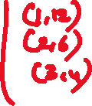

1. The H.C.F. of two numbers is 37 and their sum is 592. How many pairs of such numbers are possible?



1. 0 2) 1 3) 2 4) 4 5) 6

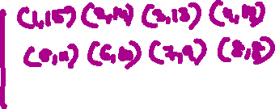

1. The ratio of three numbers is 12: 16: 20 and their H.C.F is 47. What is their L.C.M?
2. 1410 2) 2820 3) 5640 4) 11280 5) 1210
3. Find the L.C.M. and the H.C.F. of 5/24, 1 9/16, 1 3/32 and 2 29/48



1. 98 5/8 2) 109 3/8 and 5/96 3) 98 5/8 and 5/48 4) 109 3/8 and 5/48

5) 98 7/8 and 5/58



1. Find the L.C.M. and the G.C.D. of 1.6, 2.56, and 8.064
2. 210.6 and 0.16 2) 210.6 and 0.064 3) 201.6 and 0.064 4) 201.6 and 0.16

5) 806.4 and 0.064

1. Find the L.C.M. and the G.C.D of 25 x 37 x 59 and 39 x 57 x 75



1. 25 x 39 x 59 x 75 and 37 x 57 2) 25 x 37 x 57 x 75 and 39 x 59
2. 25 x 39 x 59 x 75 and 39 x 59 4) 25 x 37 x 57 x 75 and 37 x 52
3. 5) 25 x 37 x 57 x 75 and 37 x 52

